Smart Search

Feasibility Study report

Overview :
Analysis of survey reports to describe the feasibility of the software . This includes product analysis , legal feasibility , operational feasibility , economic and technical feasibility .

Problem analysis :

World has shifted from physical medium of sharing information towards the digitalized medium . Daily lots of pdf’s , docs , ppts are shared amongst students . Combining all the sharing in one portal for all the student out there seeking information is our main motive . Sharing of images is common between students but accssing information is quite a hectic task . So we have taken this to another level where images can be converted to text documents so that infomation is easily available .
So how does this works :
1) we have made use of elastic search for searching the documents .
2) Use of OCR for text conversion .

Limitations :
- Internet is required to access information from our web app .
- User must have basic knowledge of using computers and accessing internet .

Economic Feasibility:

Our’s is an open source software so this is easily accessible by anyone who finds it interesting .
So cost is not an issue for our users . Additionally as this is an open source software people can change the product or add things according to the needs . Also being open source it is legally feasible .

Conclusions From Our Survey

We surveyed, belonging to different diverse sectors like Educational Institutions (teachers/professors), students, book-lovers and general public.

1.
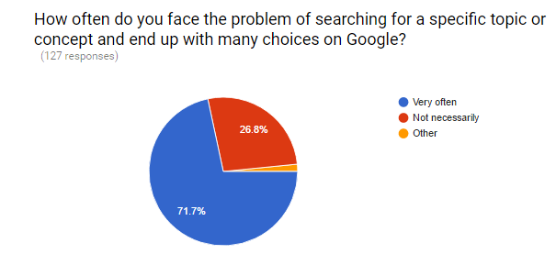

2.
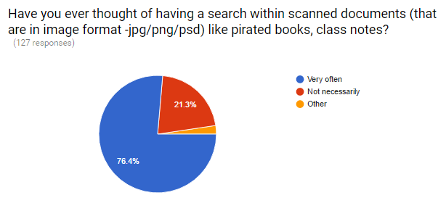

3.
